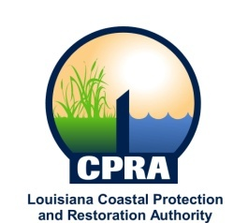

2011 Public Meetings

Garret Graves, Chairman of the Coastal Protection and Restoration Authority, and Executive Assistant to Governor Bobby Jindal for Coastal Activities has announced the public meetings schedule for the Coastal Protection and Restoration Authority and the Governor’s Advisory Commission on Coastal Protection, Restoration and Conservation. Details on each meeting will be sent out at a later date. The dates and locations of these meetings are subject to change

CPRA
January 26, 2011
Lake Charles, LA

February 16, 2011
Baton Rouge, LA

March 16, 2011
Houma, LA

April 20, 2011
Baton Rouge, LA

May 18, 2011
Baton Rouge, LA

June 15, 2011
Baton Rouge, LA

July 20, 2011
New Orleans, LA

August 17, 2011
Baton Rouge, LA

September 21, 2011
Abbeville, LA

October 19, 2011
Baton Rouge, LA

December 7, 2011
Baton Rouge, LA

Governor’s Advisory Commission
January 6, 2011
New Orleans, LA

March 10, 2011
Baton Rouge, LA

May 11, 2011
Lake Charles, LA

July 13, 2011
Baton Rouge, LA

September 14, 2011
Port Fourchon, LA

November 9, 2011
Baton Rouge, LA

